ASR 5991

Location setup – allow upload batch of new locations

Date: 2016.03.02

1.Setup -> 04.Locaiton Setup

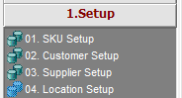

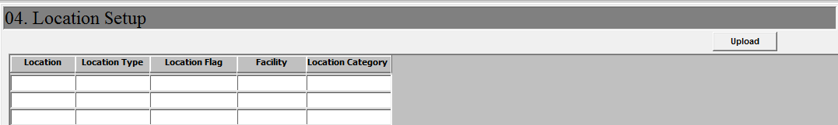

Location upload template:

1. Prepare location in below template file:

|  |  |  |  |  |
| --- | --- | --- | --- | --- |
| LOC | Locationtype | Location flag | Facility | Location category |
| 2320A1 | RACK | NONE | SLC2 | AC |
| 2322A1 | RACK | NONE | SLC2 | AC |
| 2322A2 | RACK | NONE | SLC2 | AC |
| 2324A1 | RACK | NONE | SLC2 | AC |
| 2324A2 | RACK | NONE | SLC2 | AC |

1. Delete the header row
2. Save file as “(Text) Tab-delimited..txt” text file

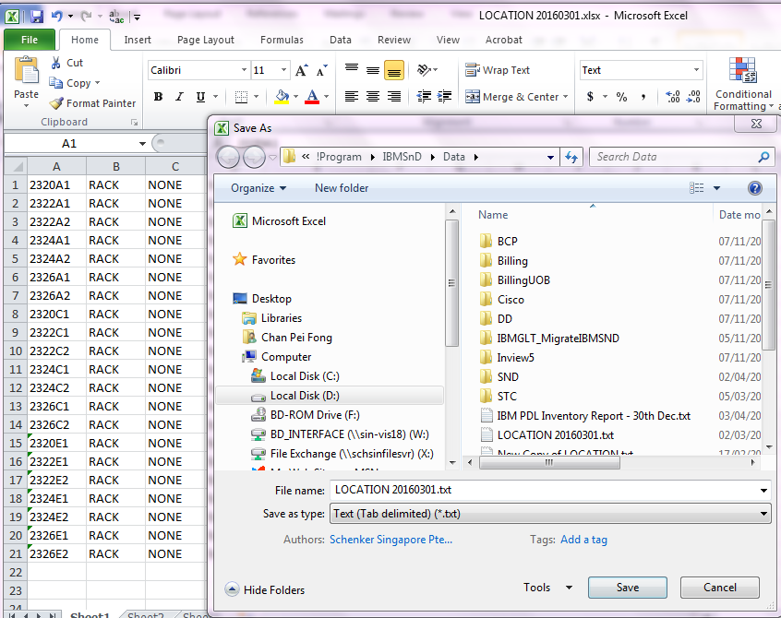

1. Location setup screen, click on [Upload]

Locate the location text file.

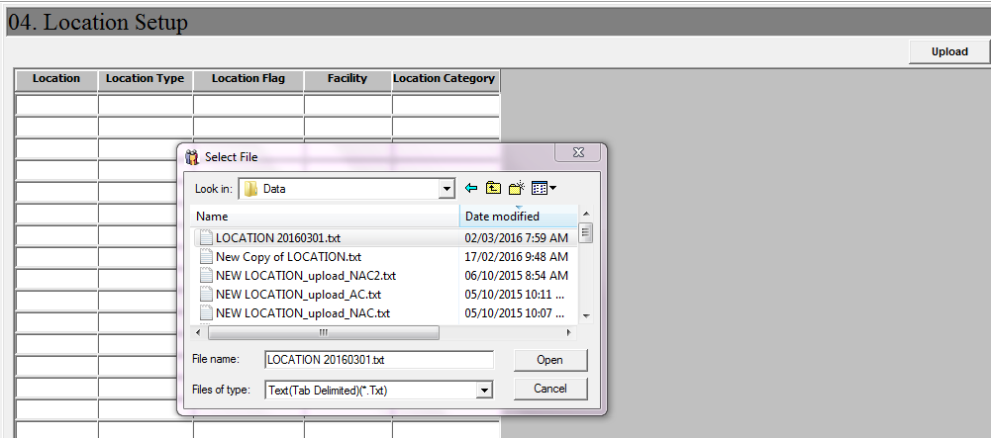

1. Click [Open] to confirm upload new location.
2. Location added into system.

